Lab 09

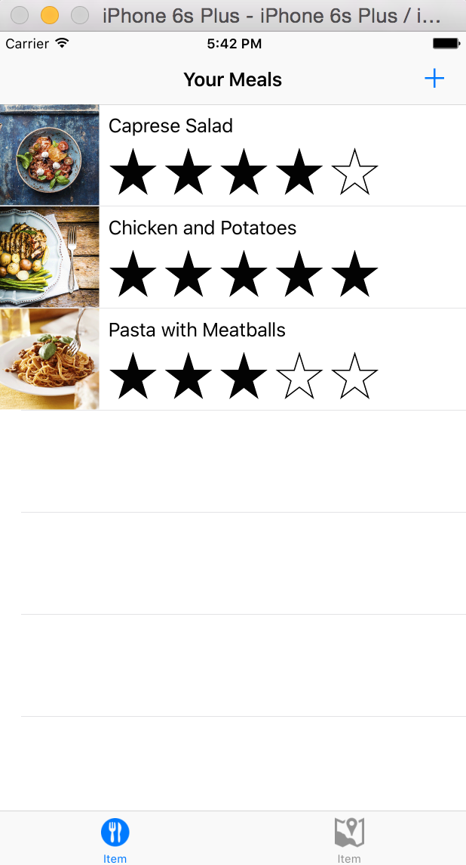

Objetivos

Crear tab view

Agregar Iconos

Manejo de mapas

Crear Tab view

1.- Add a new View Controller

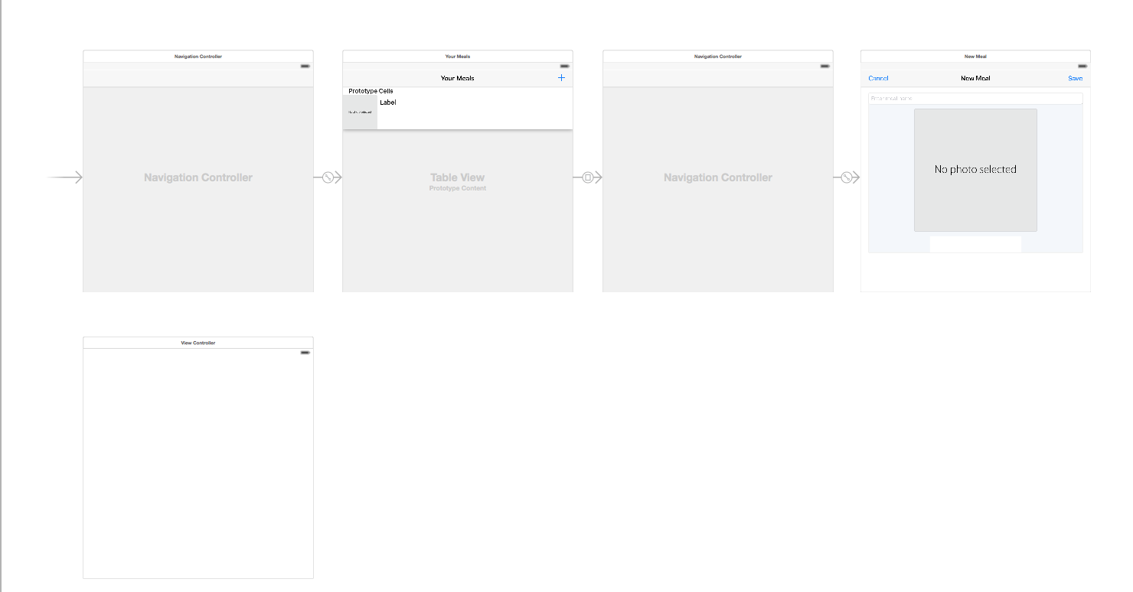

Select Navigation Controller and Edit>EmBend in Tab Bar Controller

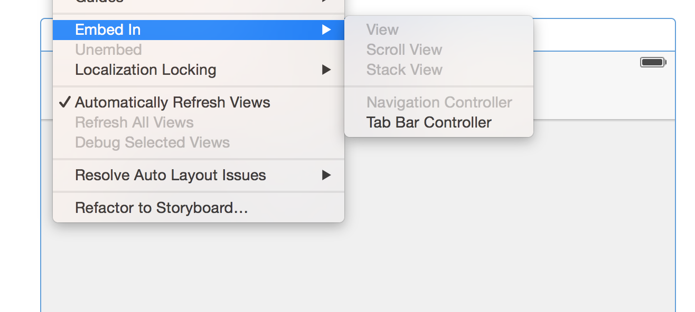

Despues de hacer Embed In Tab Bar Controller la vista debería ser:

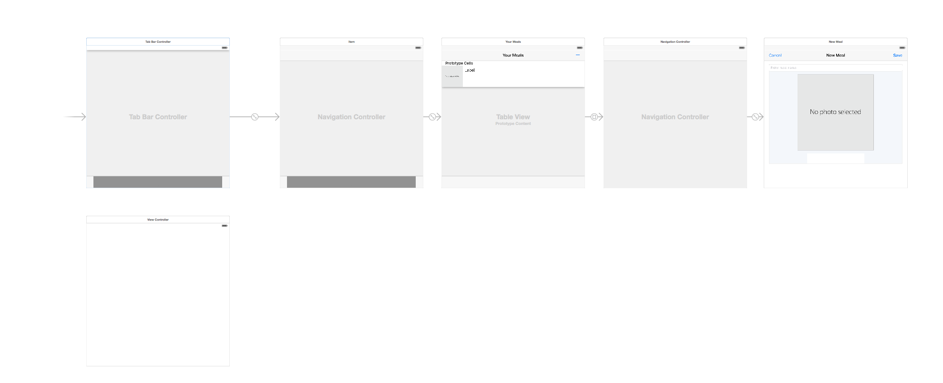

Enlazar un nuevo UIViewController

* Seleccionar Tab Controller, presionar control y crear el enlace de tipo (Relationship) view controller
* 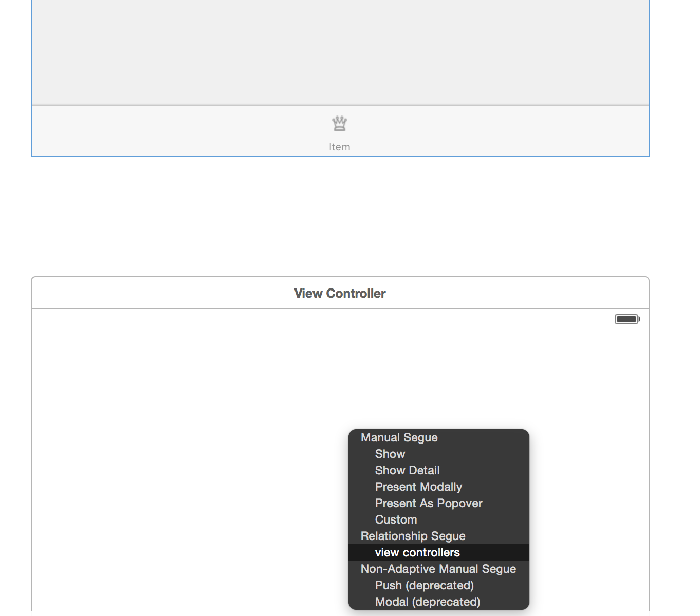

Add Image Sets

* Crear dos images Set : map y food y ponerlos a 2x !!

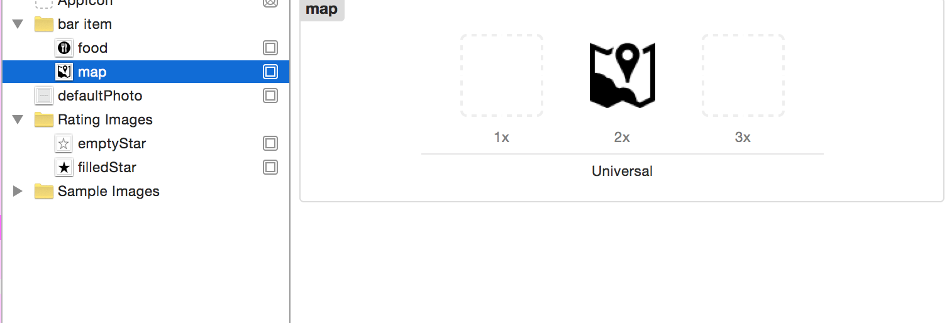

Add Icon to Navigation Tab

Seleccionar la parte inferior de las vistas

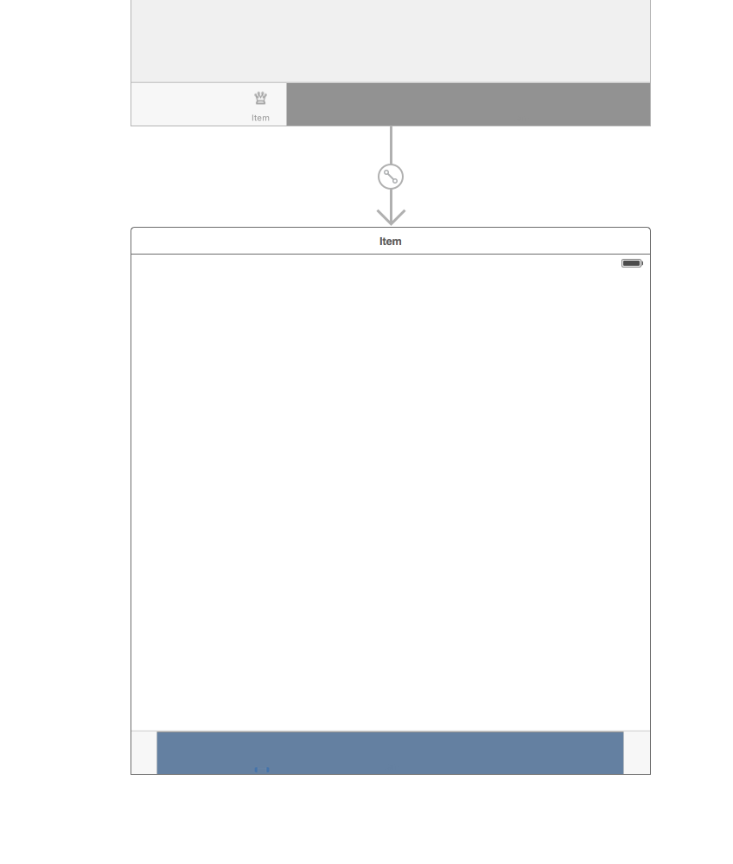

Cambiar la propiedad en el attribute inspector

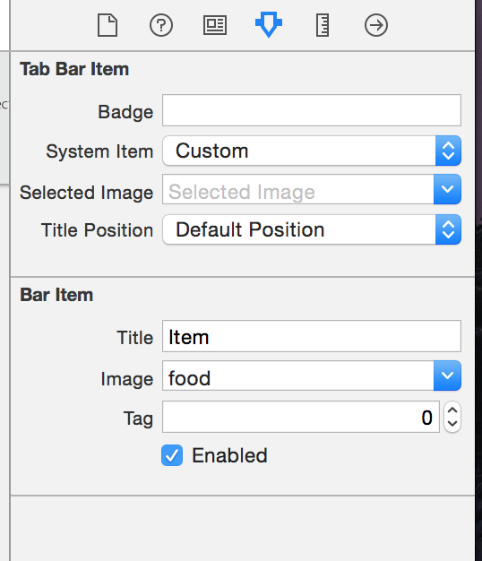

Checkpoint:

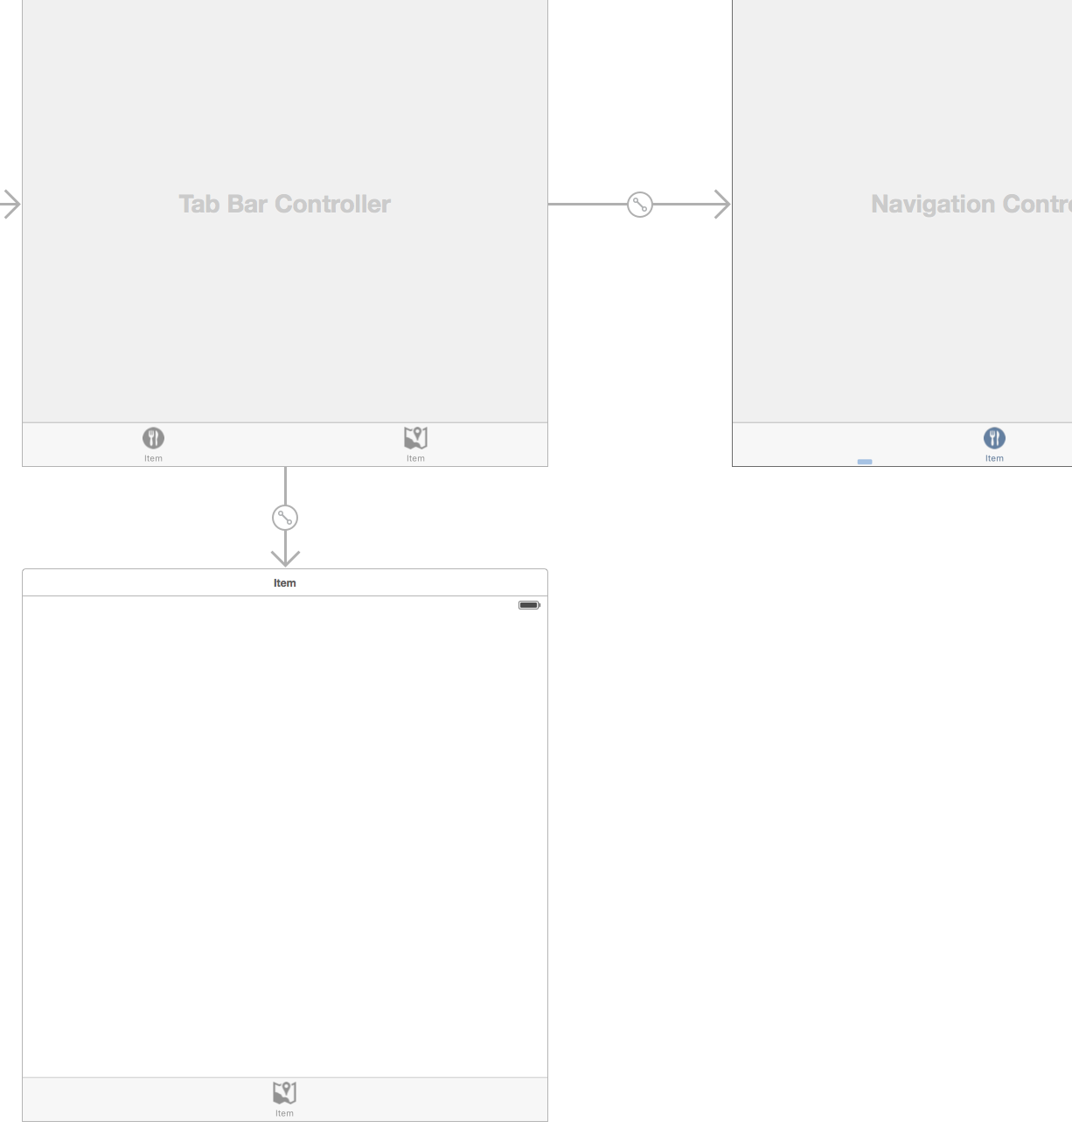

## Manejo de mapas

1.- Ir al object library y buscar mapview

2.- arrastrar hasta el view controller

3.- Correr la aplicación

4.- incluir la Librería MapKit

Agregar MapView al tab bar Map

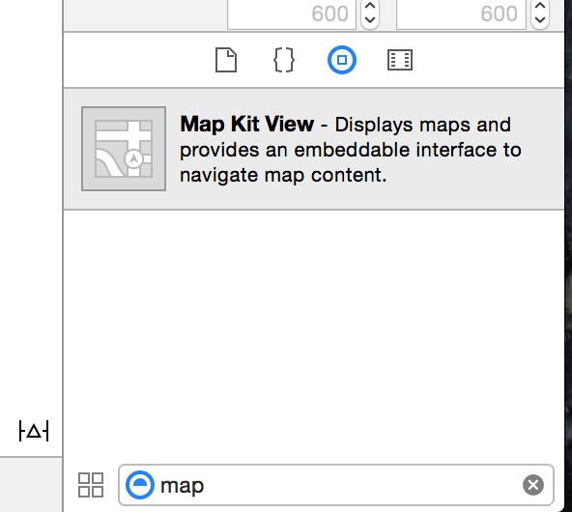

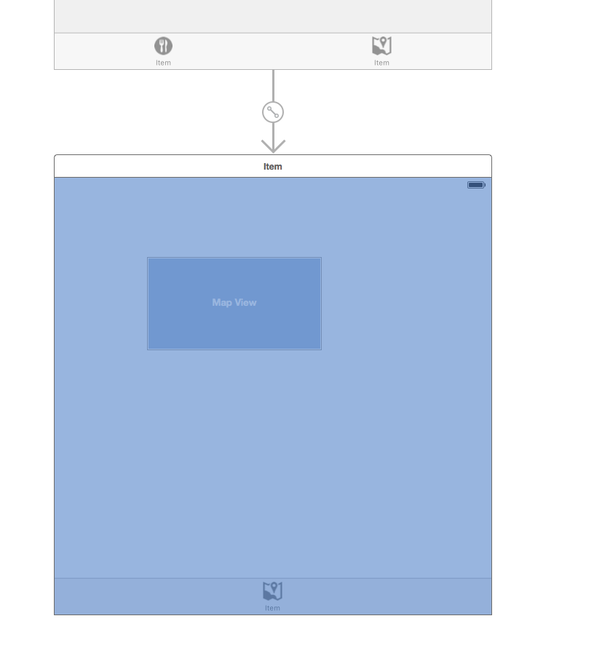

Conectar el Map View al código

1.- arrastrar la vista del map view al controlador

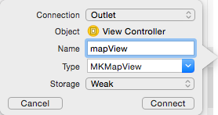

2.- Incluir MapKit Library

Click en el projecto> General> Linked Frameworks and Libraries

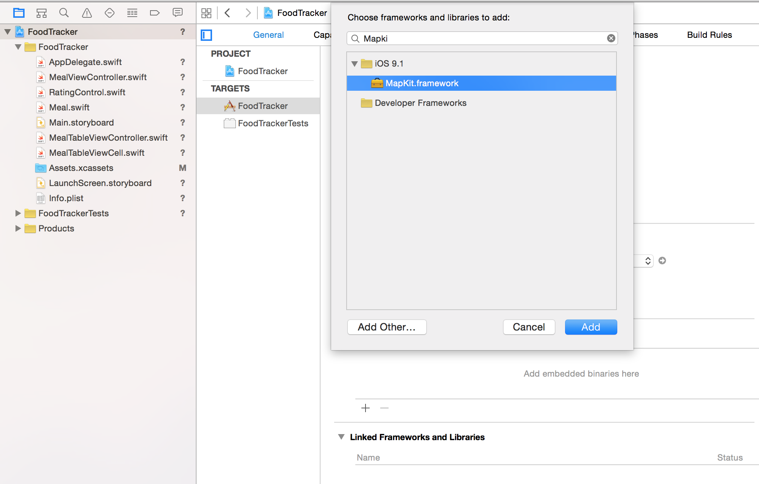

3.- Poner un Pin a una location

import UIKit

import MapKit

class MapViewController: UIViewController, MKMapViewDelegate {

@IBOutlet weak var mapView: MKMapView!

override func viewDidLoad() {

super.viewDidLoad()

let theSpan:MKCoordinateSpan = MKCoordinateSpanMake(0.01 , 0.01)

let location:CLLocationCoordinate2D = CLLocationCoordinate2D(latitude: 45.612125, longitude: 22.948280)

let theRegion:MKCoordinateRegion = MKCoordinateRegionMake(location, theSpan)

mapView.setRegion(theRegion, animated: true)

let anotation = MKPointAnnotation()

anotation.coordinate = location

anotation.title = "The Location"

anotation.subtitle = "This is the location !!!"

mapView.addAnnotation(anotation)

// custom marker

let longPress = UILongPressGestureRecognizer(target: self, action: Selector(("action:")))

longPress.minimumPressDuration = 1.0

mapView.addGestureRecognizer(longPress)

// Do any additional setup after loading the view.

}

override func didReceiveMemoryWarning() {

super.didReceiveMemoryWarning()

// Dispose of any resources that can be recreated.

}

func action(gestureRecognizer:UIGestureRecognizer) {

let touchPoint = gestureRecognizer.location(in: self.mapView)

var newCoord:CLLocationCoordinate2D = mapView.convert(touchPoint, toCoordinateFrom: self.mapView)

let newAnotation = MKPointAnnotation()

newAnotation.coordinate = newCoord

newAnotation.title = "New Location"

newAnotation.subtitle = "New Subtitle"

mapView.addAnnotation(newAnotation)

}

/*

// MARK: - Navigation

// In a storyboard-based application, you will often want to do a little preparation before navigation

override func prepare(for segue: UIStoryboardSegue, sender: Any?) {

// Get the new view controller using segue.destinationViewController.

// Pass the selected object to the new view controller.

}

*/

}

